# Very Relevant (Main Goals)

1. How many money-managing apps do you use? (eg. banking app, expense tracking app, etc.)
   1. We have a good distinction between each category
   2. We can clearly see what the majority has (more than one app for managing money)

Task: Multiple functionalities within one app (banking app, expense tracking app)

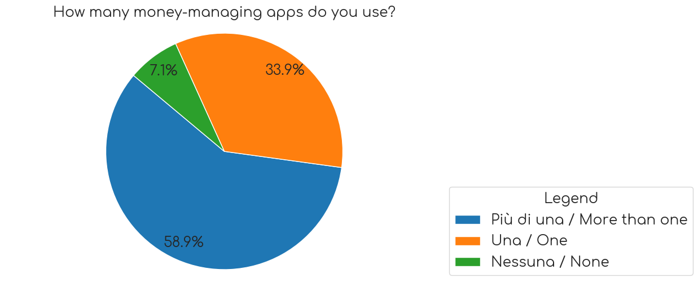

1. How useful can it be that contactless payment makes you feel the same as paying in cash?
   1. We have a good distribution of the results, specifically we have a peak between 3 and 4, on a scale from 1 (not at all useful) to 5 (very useful)

Task: Make the feel of paying contactless the same as paying in cash

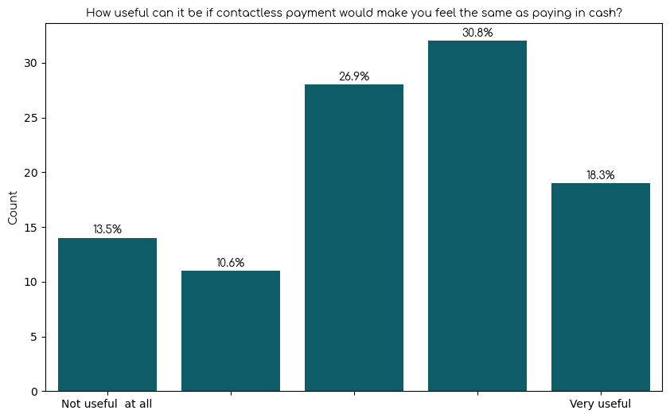

1. Would you like a more intuitive method for seeing money incoming and outgoing, perhaps even categorizing them (e.g. friends, spending, subscriptions, etc.)?
   1. We have a good result, indicating that the majority of people have voted on the upper range 4-5, with 5 indicating "I would really like that"

Task: Categorize incoming and outgoing transactions

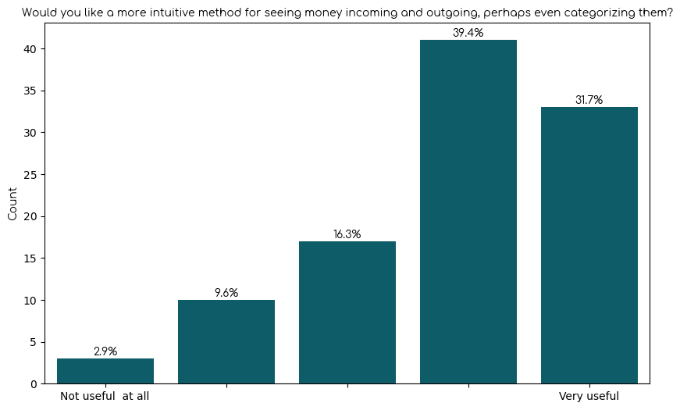

1. How intuitive do you think it would be to send money to someone using a Whatsapp-like interface?
   1. People definitely voted on the upper bound of the distribution, with the answer 5 being "Very intuitive"
   2. This entails that we should focus on implementing a Whatsapp-like interface in our solution

Task: Whatsapp-like interface for sending money

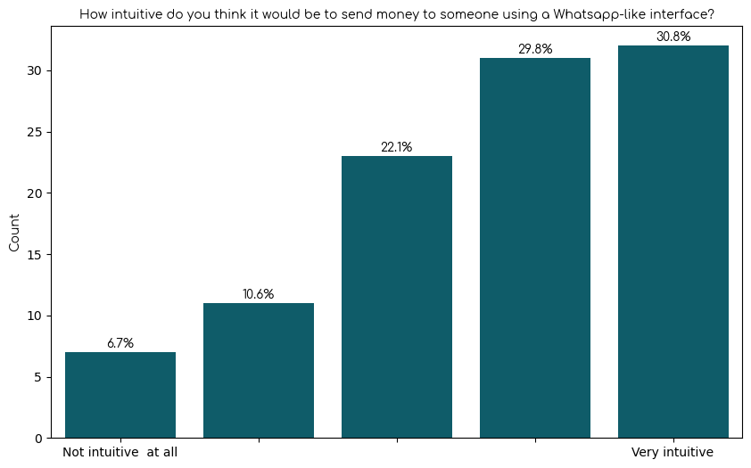

1. Have you ever felt the need to divide your available budget into multiple categories or sections for different purposes or objectives? (Budget division)
   1. We have a large majority on "Yes", thus we should keep in mind that this could be one of our main goals

Task: Budget division

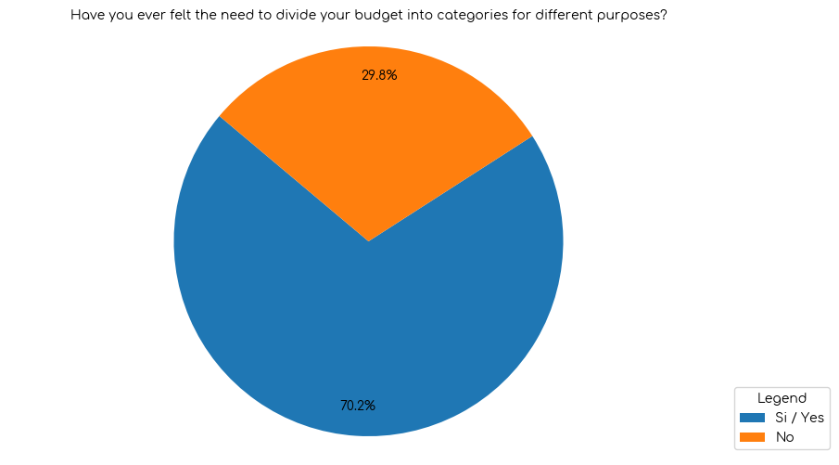

# Relevant (Optional Goals)

1. Would you like a simpler and faster way to send money to someone (e.g. splitting expenses between friends, sending money to family, etc.)?
   1. Simplifying sending money is a good practice but not necessarily the main goal since a negligible amount of people will still use other apps. Use simplification as a guideline, rather than a goal.
2. How valuable would it be for you to receive personalized recommendations or insights based on your spending habits and financial goals?
   1. The distribution shows that there is a slighter higher tail at the left side, where the answer corresponds to "very valuable"
   2. We cannot exactly accept this as a task, but we can follow this as an optional choice

# Not relevant

1. Do you feel like you've unconsciously spent too much money because of contactless payments?
   1. We have an approximate 50/50 result, so we can't actually find a majority within the answers

# Facts from general users

1. I can’t seem to save money, even though I would really like to.
   1. Majority is for very false, people seem to manage saving money
2. I sometimes get scared to spend money even though I've saved enough.
   1. Distribution of answers shows that this statement feels mostly true, but not extremely true
3. Handling money and reasoning about them provokes anxiety in me.
   1. No choice really stands out, it's a 50/50 situation
4. I often use cash.
   1. Majority of people do not use cash, given the responses that we had.

# Facts for non-banking app users

1. Why don't you use a banking app? (Only 8 answers out of 111)
   1. Age
   2. Cash preference
   3. Security concerns
   4. Lack of financial education